# Installing Microsoft SQL Server 2005 Standard

|  |
| --- |
| **Homework Requirements:**   1. Install SQL Server 2005 following the procedures below. 2. Capture a screen shot for each step and create a document. 3. This is an individual assignment. 4. The deadline is 5:30 pm on Jan 23 (Mon). 5. Submit your document via BB AND bring a hard copy to the class. |

* The installation steps listed here are from the following link with modifications. Although this document addresses SQL Server 2005 Developer Edition, the instructions are very similar for SQL Server 2005 Standard.

<http://www.sqlserverclub.com/essentialguides/how-to-install-sql-server-quick-guide.aspx>

* If your computer has SQL Server 2008 installed, uninstall it first to avoid conflicts (recommendation).

You can install 2005 in addition to 2008. In this case, you need to create a new instance while installing SQL Server 2005.

* On Windows 7 (or XP), you don’t need to create a separate service account for SQL Server 2005 that is a member of the Administrators local group. You will use your Windows admin account for simplicity.

* First, obtain MS SQL from the Microsoft Developer Network Academic Alliance (MSDNAA) site:

<http://msdn08.e-academy.com/louisville_cis>

* Create a “System Restore” point on Windows to go back to the earlier state if a problem occurs.

1. If you have a DVD, insert the DVD into the DVD drive and double-click on the icon: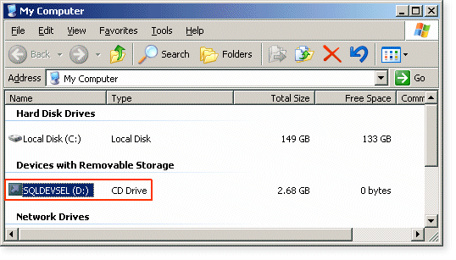

If you downloaded the file (en_sql_2005_std_x86_dvd.iso) from the MSDNAA site, extract it to a folder. Go to Servers and click on “setup.exe.”

2. The installation screen should appear: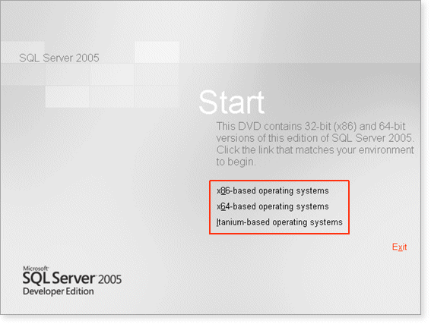

For most installations, if installing on standard 32 bit Windows XP Professional (or Windows 7), click on the x86-based operating systems option.

3. Click on Server components, tools, Books online and samples: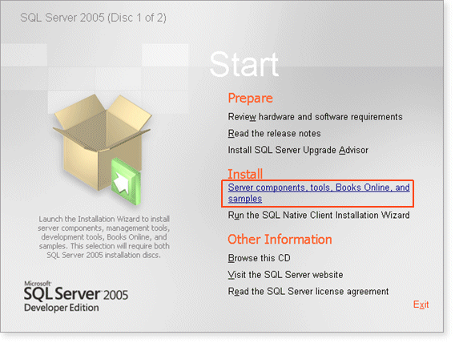

4. Read the terms and conditions of the license agreement and click the check box to accept them: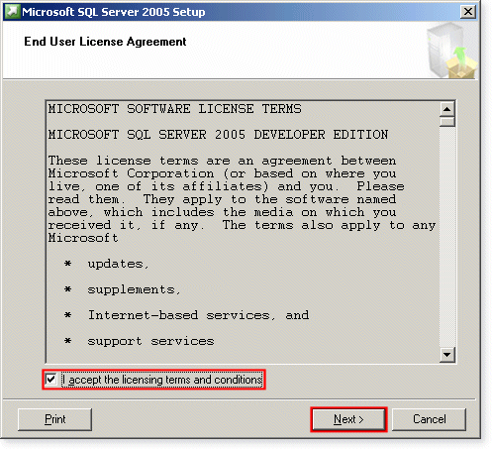

Then click **Next**.

5. The **Installing Prerequisites** screen appears: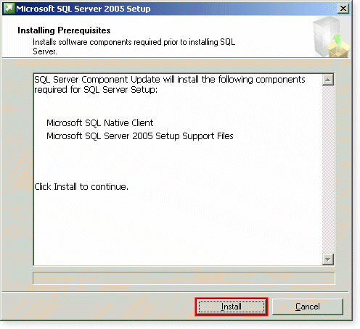

Click on the **Install** button and wait whilst the system components are configured. This may take 10-20 seconds.

6. Once the prerequisites are installed, click on **Next**: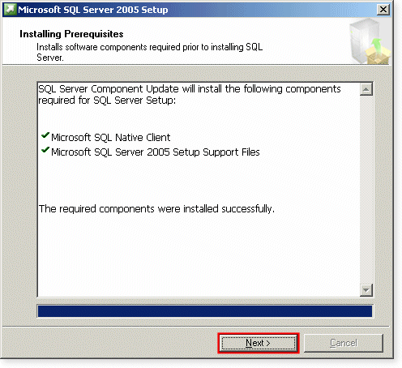

7. Wait for a few seconds for the following screen to appear, and then click on **Next**: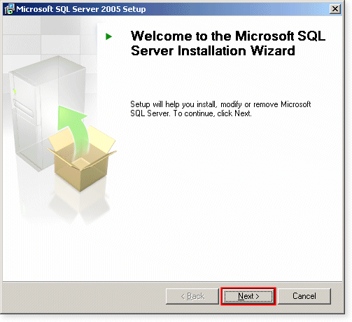

8. The **System Configuration Check** screen appears: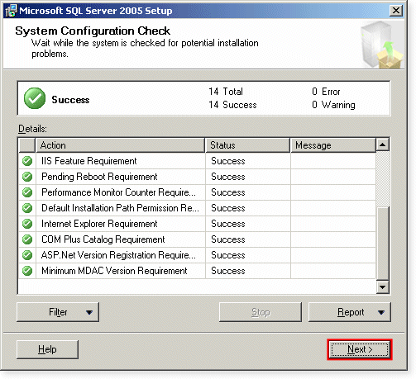

If the configuration check completes successfully (Success appears in the top panel, all ticks in the Details panel), click on **Next**.

9. Fill in the **Registration Information** details. The license is automatically filled in. 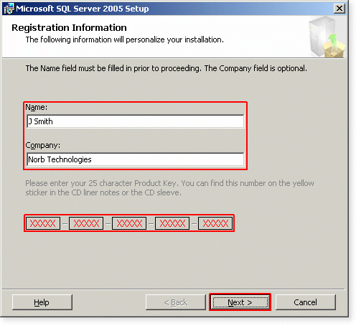

10. Select the components to install. Choose all the components for educational and testing purposes.

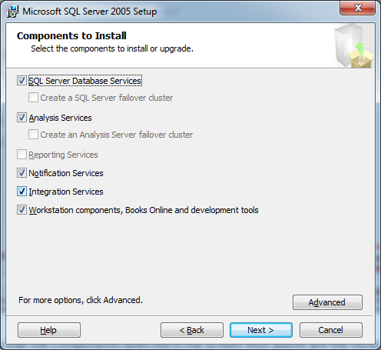

Note that the followings are the most common components that will be needed for most developers and development DBAs. However, if another component such as Analysis Services is needed, it can be added easily afterwards by re-inserting the installation DVD and re-running the setup program.

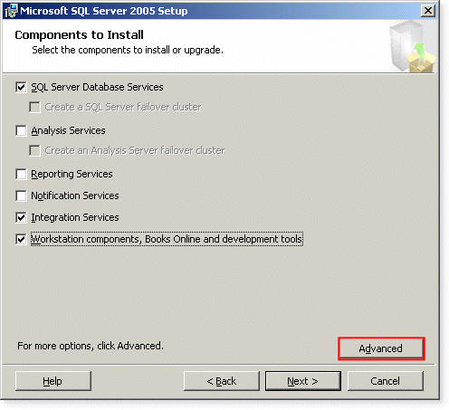

Click on the **Advanced** button to open up further options.

11. Expand Documents, Samples, and Sample Databases. Then click the button next to Sample Databases, select Entire feature will be installed on Local Hard Drive, and then click next. This will install the AdventureWorks database that you will be using later. 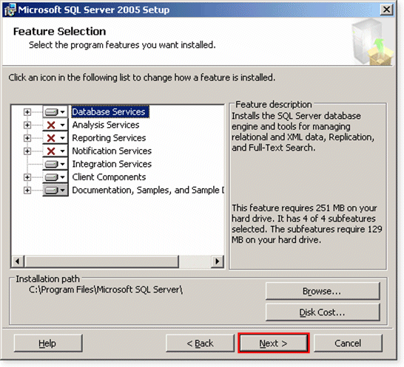

12. Select the **Default** instance:

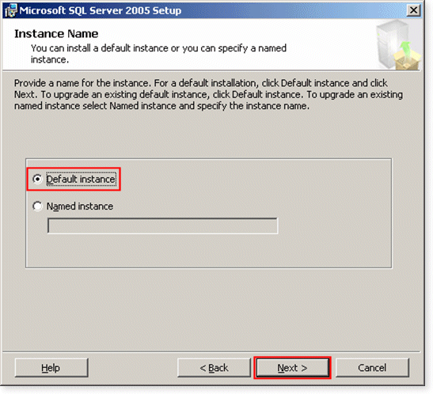

**IMPORTANT NOTE**  
If the Default instance radio button is disabled, this probably means that there is another, default instance of SQL Server 2000 or SQL Server 2008 already installed on this machine.

13. Enter the Windows account information (with admin privilege). Leave the Domain field blank. You will be using the same account for Windows 7 (XP) for simplicity.

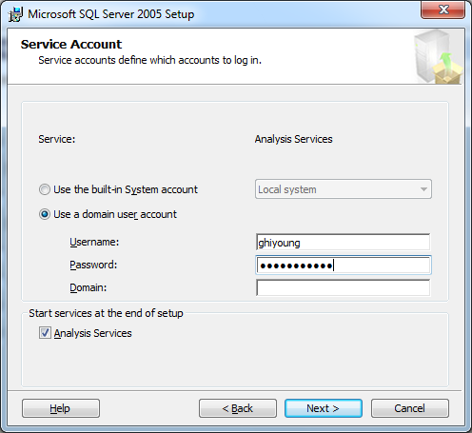

14. Change **Authentication Mode** to **Mixed Mode** and set a password for the sa logon (for example, “123456”). The user’s Windows logon name could be used as an initial password, but note that whatever is used, it should NOT be the same for each machine as the sa account gives sysadmin privileges to any user who uses it: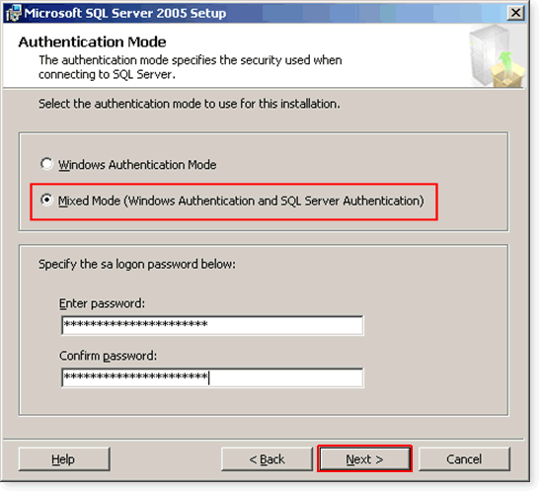

15. Select the Latin_General collation designer on the next screen, and click Next. 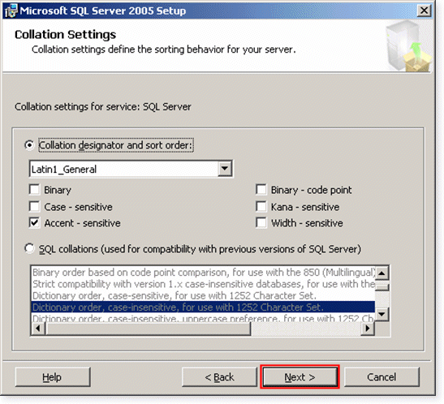

16. Select **Error Reporting and Usage** options. It’s at your discretion to select: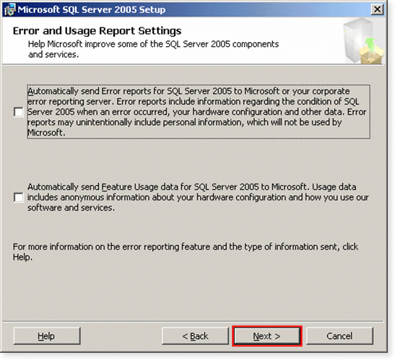

17. The pre-installation screen will now appear: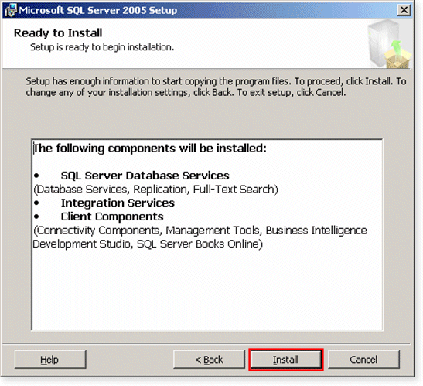

Click on **Install**.

18. The **Setup Progress** screen will appear, informing you of installation progress: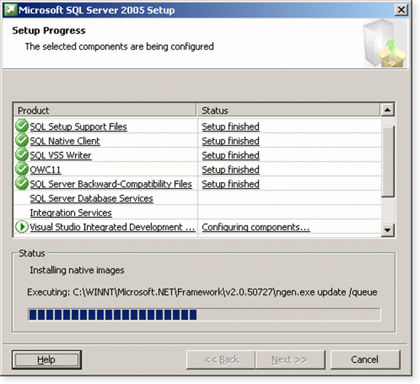

This step usually takes 10-30 minutes, but requires no user intervention - so now's a good time to take a break and make some coffee.

19. The **Setup** steps have completed: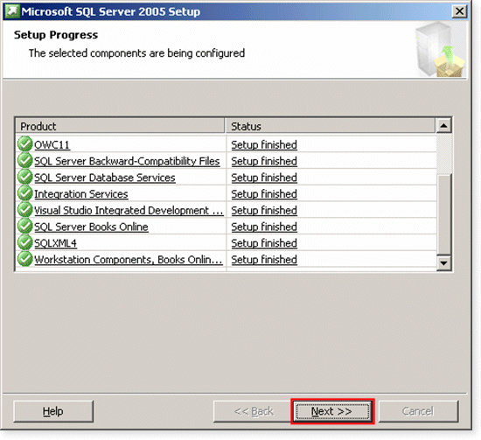

20. The **Completing Microsoft SQL Server 2005 Setup** screen will now appear: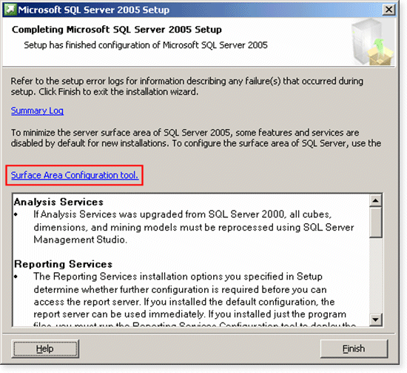

If you only want the database server to be accessible from the machine on which it is installed, click on **Finish**. SQL Server 2005 installation is now complete.

# Verifying Results

1. Click Start
2. Click All Programs
3. Click Microsoft SQL Server 2005
4. Click Configuration Tools
5. Click SQL Server Configuration Manager
6. Select SQL Server 2005 Services, and check the icons. If the icon next to SQL Server (MSSQLServer) service is green, then your installation is a success.